CURRICULUM VITAE

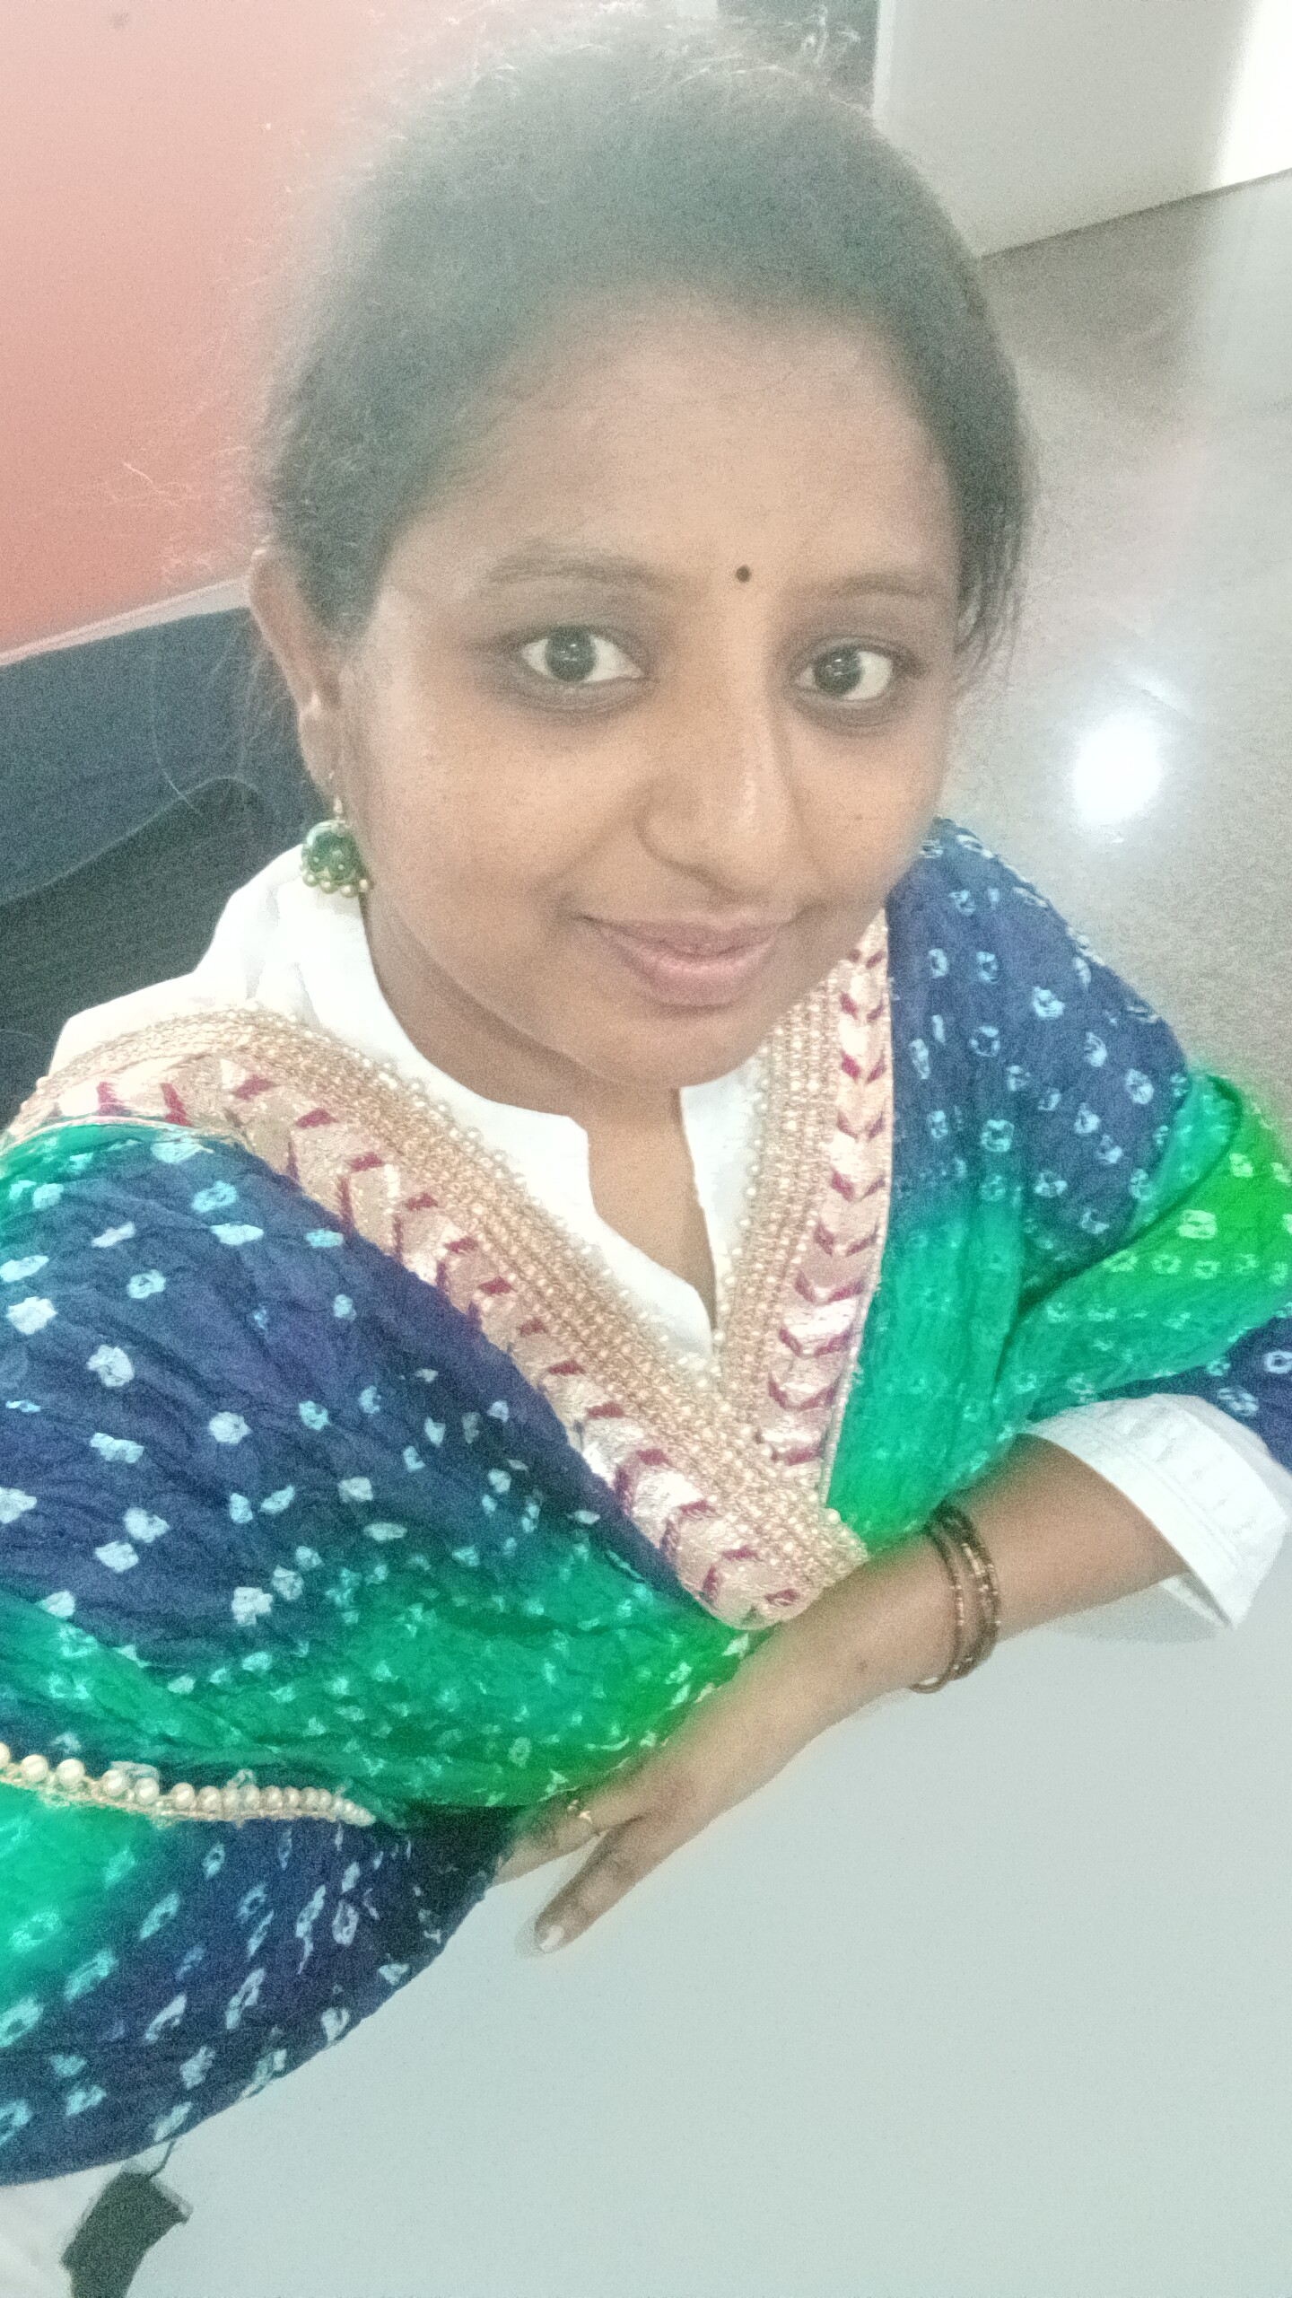
ANUPAMA SINDGI
Current Address Permanent Address
w/o Desai Maheswara #202,Pruthvi Residency
#25, 14th A cross , Bhuvaneswari nagar MLA Layout,Bannerghatta Main Road
Hebbal, kempapura Banglaore-560076 Bangalore-560024
Email- anupamasindgi@gmail.com
Mobile No. – 9916600042, 7892721114

Objective

To work in an environment where I can expand and explore my abilities and contribute to the growth of the organization.
Summary

A Technology Enthusiast with a strong teaching background. Good verbal and written communication skills. Hard working, fast learner and keeps updating with latest trends and advancements in the technology.
Technologies

Python, Pycharm, Pandas, Seaborn, Matplotlib, Streamlit, Artificial Neural networks, Machine Learning, Assembly Language Programming, C.

Certification: IIT GUVI Data Science Certification in process.

Project Details:
Twitter scrapping using Snscraper- GUI interface in steamlit, Python programming in IDE pycharm, with design of the code in modular fashion.
Link of github: https://github.com/Sindgi/capstone-project-anupama
Link of demo video: https://youtu.be/c-DYBhnwOY4

Academic Experience

- 13/08/2007 – 30/06/2013 Assistant Professor
GSSS Institute of Engineering and Technology for Women, Mysore
Affiliated to VTU, Belgaum
- 01/08/2014- 30/06/2019 – SKIT, Bangalore.
- Working in Presidency University from 29/07/2019 till January 2023.

Nov  2014\  (Part time) | M Tech in VLSI Design and Embedded System  Sri Jayachamarajendra College of Engineering  Affiliated to VTU, Belgaum | 80%  FCD
Aug  2007 | Bachelor of Engineering (E&C)  GSSS Institute of Engineering and Technology for Women, Mysore, Affiliated to VTU, Belgaum | 62%  FC
April 2004 | Diploma in Electronics & Communication final year  J. S. S. Women’s Polytechnic, Mysore | 60.71%  FC
April 2001 | S.S.L.C  St.Joseph high School (State) | 74.24%  FC

Educational Qualification

Subjects Handled:
- Artificial Neural Networks, Computational Intelligence and Machine Learning, Elements of Electronics, Network Analysis, Microelectronics, Logic Design, Microcontrollers.
- Linear IC’s (LIC), Hardware Descriptive Language (HDL) , IC fabrication Technology.
- Computer Communication Networks (CCN), Operating Systems (OS)
- Embedded System Design and Electronic Instrumentation, Information theory and coding, Satellite communication.

Labs Handled:
- Logic Design, Microcontrollers, Hardware descriptive language, VLSI
- Communication + LIC, Advanced Communication, Power Electronics

Roles and Responsibilities:
- Internal Examiner for Lab Exams of VTU
- Paper Evaluator – Microcontrollers
- Seminar and workshop coordination
- Cultural events coordination
- Guiding Project Works
- Students’ counseling and mentoring
- Accompanied students for annual sports and cultural events in other colleges

Achievements: Got 100% result in many of the subjects handled
      - Network Analysis
      - Operating System
      - Embedded System Design
      - Hardware Descriptive Language
      - Electronic Instrumentation
      - Linear IC’s and applications
      - Microcontrollers

Technical Skills:

Operating Systems: Windows
Programming Languages: C/C++
Applications: RIDE, IAR Embedded Workbench, Microwind
Technologies: VLSI, VHDL, Verilog, Micro-controller, Microprocessor, MSP430

Seminars and Workshops

- Mission 10x Program, organized by Wipro in VVCE, Mysore
- Workshop on msp430, Sri Jayachamarajendra College of Engineering
- Workshop on msp430, VVIET Mysore

Paper Presentations \ Publications

- Paper Title: “Communication Gateway for Electrical Devices using Wireless Technology”
6th IETE National Conference on RF and Wireless jointly organized by IETE Bangalore and Jawaharlal Nehru National College of Engineering, Shimoga

- Paper Title : “Designing Of Telecommand System Using System On Chip (Soc) For Spacecraft Control Applications”, 2nd International Conference On Current Trends In Engineering And Management On 17th - 19th July 2014, Organized By Vidyavardhaka College Engineering, Mysore.

Paper is published in “International Journal of Electronics and Communication Technology (Ijecet)". Issn 0976 – 6464(Print),Issn 0976 – 6472(Online),Volume 5, Issue 8, August (2014), Pp. 139-149,© Iaeme: Http://Www.Iaeme.Com/Ijecet.Asp,Journal Impact Factor (2014): 7.2836 (Calculated By Gisi)

- Paper Title : “Power Dissipation in NOC links using Novel encoding Schemes ”: A Review – Published in Grenze scientific society proceedings of international conference in engineering science and technology conducted by DBIT college Bangalore.

- Paper Tilte : “Analysis of switching activity for serial data in NOC ” – Second International conference on electrical, electronics ,communication and computer technologies and optimization techniques conducted by GSSSIETW Mysore.

Paper published in IEEE DIGITAL XPLORE link: http://ieeexplore.ieee.org/document/8284685/.

Academic Projects

- Project Title: “ RS232 to I2C Protocol Converter”
- Project Title: “Automatic Gate Opening for vehicle parking”
- Project Tilte: “Designing Of Telecommand System Using System On Chip (Soc) For Spacecraft Control Applications”

Academic Projects Guided

- Project Title: “AN EFFICIENT VLSI IMPLEMENTATION OF CDF 5/3 ARCHITECTURE ON FPGA FOR IMAGE PROCESSING APPLICATIONS.

- Project Title: “DESIGN OF WIRELESS TECHNOLOGY BASED COMMUNICATION GATEWAY FOR ELECTRIC DEVICES

- Project Title: ”IRRIGATION WATER PUMP CONTROLLER USING GSM”

- Project Title : AUTOMATIC TESTING FOR SYNTHESIZER BASED EXCITER.

- Project Title: IDENTIFICATION OF DIABETIC RETINOPATHY THROUGH LOCAL BINARY PATTERNS

- Project Title: Grid Tied Inverter

Personal Information
Name : ANUPAMA SINDGI
Permanent Address : Flat no 202 , Pruthvi Residency, kalena agrahara
Bannerghatta main Road, Bangalore-560076

Date of Birth : 25th Feb 1985
Marital Status : Married
Children : 2
Husband’s Name : Desai Maheswara
Languages known : Kannada, English, Hindi
Extra Curricular : Main Coordinator in Departmental Fest
: Main Coordinator for Cultural activities and Sports activities
Achievements : Participated in Dance, Antakshari, Dumbchards, Singing, Drawing and other cultural events and won prizes and appreciation

Declaration: I hereby declare that the information furnished above is true and to the best of my knowledge.

[ANUPAMA SINDGI]

